Research of the current situation in Latvia, concerning sexual abuse of children at residential institutions

2009
Contents

Introduction 3
- Statistics and surveys 4
- Children population and children in institutions 4
- Statistics about sexual abuse 4
- Surveys 6
- Legislation and the institutional system 7
- Children protection from sexual abuse: laws and regulations in Latvia 7
- General provisions 7
2.1. Determination and reporting 7
2.2. Concept of sexual abuse and penal offence 8
2.3. Help for victims and protection of victim during criminal procedure 11
- Summary 12
- The structure of the residential institution system 15
- Good practices and services 16
- State guarantee 16
- Preventive programs 16
2.1.“Dzimba’s safety school” for preschoolers 16
2.2.”Dzimba’s safety trip” for children 7-9 years of age 16
- Training programs 17
3.1.Training program for professionals of state and municipal institutions, who hear cases connected with protection of children’s rights 17
3.2.Training program for professionals of state and municipal institutions, who hear cases connected with protection of children’s rights 18
- Campaign 18
Conclusion 19
Used literature and resources of internet 21
Appendix No.1 22
Appendix No.2 23
Appendix No.3 24
Appendix No.4 25
Appendix No.5 26
Appendix No.6 31
Appendix No.7 32

Introduction

Child abuse is still a pending matter in Latvia, as well as still many children in comparison live at residential institutions. Therefore it was decided to do a research that would help to analyze the current situation in Latvia. This research has two goals:
- To gather and analyze available information, statistical data, legal framework of the Republic of Latvia and good practices concerning child sexual abuse.
- To gather and analyze available information and statistical data regarding children who live in residential institutions.
Gathering and analyzing available information, legal framework and statistical data is the method used in this research.

This research is based on child abuse definition introduced by World Health Organization (WHO): Child abuse or maltreatment constitutes all forms of physical and/or emotional ill treatment, sexual abuse, neglect or negligent treatment or commercial or other exploitation, resulting in actual or potential harm to the child's health, survival, development or dignity in the context of a relationship of responsibility, trust or power (WHO, 1999).
World Health Organization also introduces the definition of child sexual abuse, which will also be used in this research. This definition prescribes, that child sexual abuse is the involvement of a child in sexual activity that he or she does not fully comprehend, is unable to give informed consent to, or for which the child is not developmentally prepared and cannot give consent, or that violate the laws or social taboos of society. Child sexual abuse is evidenced by an activity between a child and an adult or another child who by age or development is (WHO, 1999) in a relationship of responsibility, trust or power, the activity being intended to gratify or satisfy the needs of the other person. This may include but is not limited to:
- The inducement or coercion of a child to engage in any unlawful sexual activity.
- The exploitative use of a child in prostitution or other unlawful sexual practices.
- The exploitative use of children in pornographic performances and materials (WHO, 1999)

Children who are left without care in Latvia receive extra-familial care, which is ensured with a guardian, foster family, childcare institution for orphans and children who have been left without parental care. In turn, child care institution is defined as an institution in which social care and social rehabilitation for orphans and children left without parental care, as well as children for whom social rehabilitation is necessary or special care due to their state of health, is ensured. (Protection of the Rights of the Child Law, 1998).

I. Statistics and surveys

1. Children population and children in institutions
There are 2,2 million inhabitants in Latvia, out of which 408,2 thousand are children from 0 till 18 years of age. Part of these children live in residential institutions. Since year 2006 the number of children who need extra-familial care has increased: 1872 children in year 2006, 2064 children in year 2007 and 2337 children in year 2008 (see table No.1 in appendix No.1). But at the same time the number of children living in institutions has decreased: 923 children in year 2006, 672 children in year 2007 and 735 children in year 2008. Rest of these children receives other kind of extra-familial care – guardian or foster family is provided. At the same time there is a tendency of the number of children living in residential institutions to decrease: 3093 children in year 2004, year 2005 - 2881 children, year 2006 – 2621 children, year 2007 – 2207 children, but 2182 children in year 2008 (see Figure No.1 in appendix No.1).

2. Statistics about sexual abuse
There is no united system in Latvia that would list all registered violence cases. There are no separate statistics on children who have suffered from violence and live in institutions. Available statistical data in Latvia that reflects registered violence cases is registered crime against minors, number of heard cases in court and number of registered cases of State inspectorate for protection of children’s rights of Latvia.
Statistical data provided by State Police is prepared according to Criminal Law of Latvia. Crime against minors is especially marked out. There are five articles in Crime Law concerning sexual abuse: rape, forcible sexual assault, immoral acts, sexual intercourse with person who has not attained the age of sixteen years and compelling engaging in prostitution (see Table No.2 in appendix No.2). There are 165-516 registered crime cases involving sexual abuse against minors every year, accordingly year 2001 – 198 cases, 2002 – 189, but 2003 – 212, 2004 – 516, 2005 – 462, 2006 – 165, 2007 – 351 and 2008 – 305 cases. During the last two years the number of registered crime cases involving child sexual abuse is relatively constant (see Figure No.2 in appendix No.2)
Unsteady dynamic is noticed concerning the registered cases involving rape against minors. During the period of year 2001-2003 the number is rather unchanging, accordingly 69 cases in 2001, 51 cases in 1002 and 73 cases in 2003. But then in 2004 there is a rapid growth of registered cases involving rape against minors – that is 266 cases. In turn, afterwards in 2005 there is a rapid drop – 165 cases, but during the last three years the number is relatively unchanging, accordingly 38 cases in year 2006, 36 – 2007 and 41 cases in 2008.
Unstable dynamics can be observed regarding the registered cases involving forcible sexual assault against minors. The number of registered cases has tendency both to increase and decrease, accordingly 74 cases in 2001, 53 – 2002, but 54-2003, 106-2004, 165 – 2005, 78-2006, 133-2007 and 66 cases in 2008.
The number of registered cases involving immoral acts against minors during the period between years 2001-2003 is rather similar, accordingly 55 cases in 2001, 85 – 2002 and 72 cases in 2003. Then there is a rapid growth of number of registered cases involving immoral acts against minors in 2004-2005, accordingly 144 cases in 2004 and 163 cases in 2005. Afterwards there is a rapid drop in turn – only 29 cases in year 2006, but during the last two years the number of registered cases is almost constant, accordingly 156 cases in 2007 and 157 cases in 2008.
Statistical data regarding registered cases involving sexual intercourse with person who has not attained the age of sixteen years is available only starting from year 2005 when no case was registered. During the next years the number of registered cases involving sexual intercourse with person who has not attained the age of sixteen years has tendency to increase, accordingly 20 cases in 2006, 26 – 2007 and 41 registered cases in 2008. It could mean that society and professionals have started to recognize sexual intercourse with person who has not attained the age of sixteen years as crime case and react accordingly – reporting about such violations of Criminal Law.
Statistical data regarding registered cases involving compelling engaging in prostitution against minors is also available only starting from year 2005. There is no registered case during the period of years 2005-2008. Such statistical data could mean that there is no reporting done about cases involving compelling engaging in prostitution. That points out the necessity to educate professionals, as well as to raise the awareness of society, that this is a crime case.
Another way how to look at statistical data involving child sexual abuse is number of heard cases at court (see table No.3 in appendix No.3). Statistical data on heard cases at court is available only starting from year 2005. There is separate data regarding the number of heard cases involving rape at court. In turn the data on number of heard cases involving forcible sexual assault, immoral acts and sexual intercourse with person who has not attained the age of sixteen years at court are summed. Considering all heard cases at court involving child sexual abuse relatively unchanging dynamics are observed, accordingly 167 cases in year 2005, 258 – 2006, 119 – 2007 and 112 cases in year 2008.
Number of heard cases involving rape at court has tendency to decrease, accordingly 76 cases in year 2005, 69 – 2006 and 39 cases in year 2007 and 2008 (see Figure No.3 in appendix No.3), but that is according to number of registered crime cases. For example, there were 41 cases involving rape in year 2008 and there are 39 heard cases at court this year, but one should take into account that not all registered crime cases are heard at court the same year.
There is relatively unchanging dynamics regarding other types of sexual abuse crime against minors (forcible sexual assault, immoral acts and sexual intercourse with person who has not attained the age of sixteen years), accordingly 91 cases in year 2005, 59 – 2006, 80 – 2007 and 73 cases in year 2008.
State children rights protection inspectorate was established in 2006 and one of the structural units is Children Hotline where violation of children rights is being reported, including child sexual abuse. Most of the time the reporters are children themselves. Data gathered by State children rights protection inspectorate show that there are 425 phone calls reporting sexual abuse in 2006, 254 – 2007 and 169 phone calls in 2008.
Statistical data of the Children hotline of State children rights protection inspectorate is the only available data in Latvia about sexual abuse cases in institutions (see table No.4 in appendix No.4). There are 5 phone calls reporting sexual abuse from equals of age in extra-familial care in 2006, but one phone call in 2007 and 2008. There was one phone call reporting sexual abuse from teachers in residential institutions in 2006, no phone call received in 2007, but 2 phone calls in 2008.
Much more phone calls are received about possible sexual abuse in educational institutions. There were 137 phone calls in 2006 that reported sexual abuse from equals of age, and then there is a rapid drop during next years, accordingly 35 phone calls in 2007 and 13 phone calls in 2008. Number of received phones reporting sexual abuse from teachers has also tendency to decrease, accordingly 42 phone calls in 2006, 16 – 2007 and 10 phone calls in 2008. State children rights protection inspectorate reacts to phone calls received performing necessary actions and that might be the reason for why the number of cases decrease.
In total there have been 113 phone calls reporting sexual abuse in family from parents, grandparents, stepfather or stepmother, as well as brothers and sisters in 2006. During next years number of received phone calls reporting such crime has tendency to decrease, accordingly 77 phone calls in 2007 and 63 phone calls in 2008.
State children rights protection inspectorate receives phone calls reporting sexual abuse, but for certain reasons it is not always possible to find out more specific information about reported cases. There were 56 such phone calls in 2006, 104 – 2007 and 169 phone calls in 2008.

3. Surveys
During last 10 years there is only one scientific survey done with the aim to find out the frequency of abuse presented by children. In “Study of coefficient factors of marriage, birth and positive relationships between children and parents.” (Sebre, S., Ļebedeva, L., Trapenciere, I., 2004) pupils of 5th (M=11.5) and 9th (M=15.2) grade were surveyed using self-esteem questionnaires. This survey should be considered as representative.
Survey results show that 3% out of all school children from 5th grade declared that they suffer from sexual abuse, including 4,5% of all surveyed boys from 5th grade and 1,5% of all surveyed girls from 5th grade. In turn in group of 15 year olds, 10% of all children declared that they suffer from sexual abuse, including 5% of all surveyed boys from 9th grade and 14,1% of all surveyed girls from 9th grade (see Figure No.4 in appendix No.4).
These results show that adolescent girls (as well as their parents and teachers) should be especially careful, cautious and informed about the issue of violence and possibilities to avoid it, as well as possibilities (in case of necessity) to look for help. It could be possible that the increase of sexual abuse is connected with the fact that genital maturation of girls is more active and they themselves have more reinforced and vivid interest about the opposite sex. They more often find themselves in situations that hold potential risk. Adolescents of this age should hear more about healthy relationships with opposite sex, risks and possibilities of building relationships. Parents of adolescents should have more information about coefficient approaches of positive relationships, in handling the specifics of adolescent’s intensified emotional stage of development.

II. Legislation and the institutional system

1. Children protection from sexual abuse: laws and regulations in Latvia

The most important laws and regulations that define standards for children protection from sexual abuse and exploitation are Protection of the Rights of the Child Law, especially Section 15., 51., 52 and Criminal law. Several aspects of children rights regulate Criminal Procedure Law, Law on Orphan’s Court and Regulations issued by the Cabinet of Ministers, that define competence and procedures of different institutions how to ensure guarantees the rights of child in case of sexual abuse. Latvia is mandatory to several international laws and regulations on children protection from sexual abuse, including UN Convention on the Rights of the Child, especially Section 19. and 34; Council of Europe framework Decision 2004/68/TI of December 22, 2003 on combating sexual exploitation of children and child pornography; UN Convention on the Rights of the Child of May 25, 2000 additional protocol on children trafficking, children prostitution and children pornography, that defines standards for children protection from commercial sexual exploitation, etc.

2. General provisions
2.1. Determination and reporting
Protection of the Rights of the Child Law Section 51, part 3 prescribes that every person has the duty to inform the police or another competent institution regarding violence or any other criminal offence directed against a child. For failing to inform, the persons at fault shall be held to liability as prescribed by law.
Criminal Law Section 315 prescribes criminal liability for a person who commits failing to inform, where it is known with certainty that preparation for or commission of a serious or especially serious crime is taking place. In accordance with Criminal Law, most of the crime cases involving child sexual abuse are considered as serious or especially serious crime.
Nevertheless, except for norms of Protection of the Rights of the Child, particular laws that regulate the procedure of medical, educational, etc., institutions do not enclose responsibility for a person to report to responsible institutions about sexual abuse – according laws and regulations usually prescribe restrictions about informing third party in order to ensure protection on person’s data. For example, in accordance with Criminal Law section 161, for a person who commits an act of sexual intercourse, or pederastic, lesbian or other unnatural sexual acts of gratification, with a person who has not attained the age of sixteen years and who is in financial or other dependence on the offender, or if such offence has been committed by a person who has attained the age of majority, the offender is applicable to sentence. It is very important that it is reported about a possible crime case against minor and in such cases the best possibility is for medical practitioner to report, who do the check-up of pregnant minor. However, providing information to law enforcement institutions about cases when person who has no attained the age of sixteen is pregnant often depend on child’s parents, because medical practitioner understands reporting differently, and in many cases consider that they do not have to turn to police. One should take into account that Medical Treatment Law Section 50 defines procedure how medical practitioner can provide information obtained during the medical treatment process regarding the private life of a patient and his or her closest relatives. In the same section part 3 prescribes that information regarding a patient shall be provided to a court, the Office of the Prosecutor, the police, the State institution responsible for the child and family matters (State protection of the rights of the child inspectors), an Orphan’s court (a parish court), as well as to investigative institutions only at the written request of such institutions if there is a permission signed by the head of the medical treatment institution.
At the moment the obligation of medical practitioner to report about abuse is defined in Regulation No.719 issued by the Cabinet of Ministers on September 8, 2008 “Procedures for the Provision of Emergency Assistance to a Child Who Has Suffered from Illegal Activities” Section 5. But it should be mentioned that Regulations issued by the Cabinet of Ministers are lower rank regulations than Medical Treatment Law.
From the abovementioned it can be concluded that in the level of regulations and laws it is necessary to evaluate all according norms and consider possibility to make amendments in several laws.

2.2. Concept of sexual abuse and penal offence
In accordance with Protection of the Rights of the Child Law Section 1, part 10, sexual abuse is involving of a child in sexual activities that the child does not understand or to which the child cannot knowingly give consent.
In accordance with Protection of the Rights of the Child Law Section 15, part two, a child has the right to be protected from physical and mental exploitation, from sexual exploitation and seduction, and from any other forms of exploitation, which may in any way harm the child.
In accordance with Protection of the Rights of the Child Law Section 51 “Protection of the Child from Illegal Activities”, part one forbids violence against a child, encouraging or forcing a child to take part in sexual activities, exploitation or involvement of a child in prostitution, determined the persons at fault to be held liable as prescribed by law.
Offenses with character of sexual abuse which are criminal acts are defined by Criminal Law Chapter XVI „Criminal Offences against Morals, and Sexual Inviolability”. Regarding child sexual abuse they are:
- Rape: an act of sexual intercourse by means of violence, threats or taking advantage of the state of helplessness of a female victim;
- Forcible Sexual Assault: pederastic or lesbian or other unnatural sexual acts of gratification, if such acts have been committed using violence or threats or by taking advantage of the state of helplessness of a person
- Sexual Intercourse, Pederasty and Lesbianism with a Person who has not Attained the Age of Sixteen Years and who is in financial or other dependence on the offender, or if such offence has been committed by a person who has attained the age of majority;
- Immoral Acts: commits immoral acts with a minor against the will of the minor or if such have been committed by a person who has attained the age of majority;
- Compelling Engaging in Prostitution person who has not attained the age of sixteen years: compelling the engaging in of prostitution, procurement of persons for prostitution, inducing or compelling a minor to engage in prostitution, or commits providing premises to minors for purposes of prostitution, inducing or compelling a juvenile to engage in prostitution.
Regarding child sexual abuse there is one of the highest thresholds in Latvia regarding agreeing willingly to sexual relationships – 16 years of age (in comparison, for example, in Estonia – 14 years, Ireland – 17 years, Portugal – 13 years of age). Latvian Criminal Law does not prescribe sentence for sexual act with a person who has not attained the age of sixteen years, unless it happens against person’s free will.

Criminal Law contains all criminalized sexual offences against children on international level, which can be valued positively. Including Criminal Law in means of criminal offences conform Council of Europe framework Decision 2004/68/TI of December 22, 2003 on combating sexual exploitation of children and child pornography, as well as according to initial valuation results the Council of Europe Convention on the protection of children against sexual exploitation and sexual abuse of October 25, 2007, which is the first wide range international document that deals with not only commercial sexual exploitation, but also sexual abuse issues (see table No.5 in appendix No.5).

As one of especially positive aspects should be mentioned the fact that since October 30, 2008 Criminal Law is supplemented with Section 162^{1 “}Compelling Engaging in grooming” that makes only lately identified type of sexual abuse such as encouraging child to engage in sexual act using electrical communication facilities – internet, mobile phone – a criminal act. That way Latvia has quickly reacted to child exploitation that is becoming more and more popular in modern world of electrical communication facilities.

At the same time attention should be paid to that several norms of Criminal Law which should be considered as out-of-date in moral sense and inadequate to legal standards of nowadays. As one of examples should be mentioned the mutual correlations of Sections 159 and 160 of Criminal Law. Section 159 prescribes responsibility for an act of sexual intercourse by means of violence, threats or taking advantage of the state of helplessness (rape), if victim is female, while Section 160 foresees responsibility for different type of sexual abuse (pederastic or lesbian or other unnatural sexual acts of gratification, if such acts have been committed using violence or threats or by taking advantage of the state of helplessness of a person), including analogical abuse of rape, if victim is male. Nevertheless the applicable sentence of Section 160 is lower than Section 159, thus legislator considers male sexual abuse less dangerous and victim is less traumatized comparing to analogical action against female.

This discrimination was partly eliminated at the end of year 2008, when with the help of amendments the sanctions of Section 159 and 160 of Criminal Law were evened if minors were involved. Nevertheless different are sanctions in case involved minors 14-18 years of age.

Although during discussions of experts of criminal law there is an idea to “join” Section 159 and 160 Criminal Law in order to totally eliminate circumstances of discrimination depending of victim’s gender and follow only the severity of offence, but it there is no united opinion about this issue.

Analyzing Criminal Law in total, another aspect should be mentioned – issue about criminal liability limitation period (i.e., period of time after which offender cannot be called to criminal liability), which so far is not in contradiction to international legal norms mandatory to Latvia, nevertheless it should be solved in order to ensure the best legal system for best interests and rights of the child. In several recommendations of international organizations, as well as in Council of Europe Convention, it was indicated that at least for the most serious child sexual abuse cases criminal liability limitation period should be until child can turn to law enforcement institutions themselves after certain time of child’s coming of age. These kinds of guarantees are important for cases when violence has taken place in family and parents have hidden that (often mother hides or ignores her partner’s criminal act towards child). Criminal liability limitation period of Latvian Criminal Law at the moment is connected with severity of offence and applicable sentence to it, but not always the criminal liability limitation period exceeds the moment of child’s coming of age.

Although the norms of Criminal Law cover all kinds of child sexual abuse and mostly foresee severe punishments, there are big problems to introduce the norms in practice. One of the biggest problems is that person directing the proceedings valuate the severity of offence by physical injuries of child, not taking into account psycho-emotional consequences, which is done to victim through any kind of sexual abuse. For example, in one verdict in year 2008 it was stated that the accused forced his minor foster-sister to satisfy him orally, as well as performed different other immoral acts in order to satisfy his sexual drive which is qualified as serious criminal act. Although the centre of crisis in it’s conclusion indicated that victim has serious functional disturbance as the result of abuse – officious thoughts and memories about traumatic situations that happened, depressive thoughts and worries about future, and in order to reduce all that, long-term help is needed. The court concluded that criminal act performed does not have serious consequences, besides accused plead guilty and acknowledged offence, therefore imprisonment is not necessary.

Also it is not taken into consideration that children, especially very young children or children with special needs, do not understand and cannot evaluate the character of criminal acts performed and therefore cannot testify precisely. In one case prosecutor pronounced the case closed because it was impossible to state victims – suspect’s daughter legal qualification of committed injury. Although the expertise established equipollent fact of sexual abuse (so called – rip of hymen), prosecutor came to a conclusion that testimonies of 5-year-old girl are “conflicting” and she cannot precisely explain the conditions of how the injury happened, therefore case should be closed. In another case the criminal procedure was closed, because victim - minor didn’t take the offence seriously (different types of sexual character touches), besides the suspect was so drunk that there were several episodes he could not remember, girl’s parents testified that suspected is a friend of family and a very good person.
Adequate application of Criminal Law is burdensome because it is hard to separate structure of Section 160 and 162 (forcible sexual assault, immoral acts with a minor) and often the qualifications (and thus the punishment, which in Section 162 is much less) depend on procedure guides. Supreme Court has also stated that there are problems regarding qualification of sexual crime against children according to several sections of Criminal Law. Supreme Court also pointed out that analyzing the practice of punishment assignation of criminal cases involving forcible sexual assault and immoral acts the prosecutor’s pleaded and judgment not always is adequate to performed criminal act and personality of guilty.

2.3. Help for victims and protection of victim during criminal procedure
Protection of the Rights of the Child Law Section 51 part two prescribes that a child who is a victim of a criminal offence, exploitation, sexual abuse, violence or any other unlawful, cruel or demeaning acts, shall, in accordance with procedures prescribed by the Cabinet, be provided with emergency assistance free of charge, in order that a child may regain physical and mental health and reintegrate into society. Such medical treatment and reintegration shall take place in an environment favorable to the health, self-esteem and honor of a child, carefully guarding the child’s intimate secrets.
Protection of the Rights of the Child Law Section 52 prescribes that special institutions or sections in general medical institutions shall be established and special resources allocated in the State budget for the medical treatment and rehabilitation of a child who has suffered as a result of violence. Expenditures for the medical treatment and rehabilitation of the child shall be covered by the State and shall be collected from the persons at fault by subrogation procedures.
In accordance with Protection of the Rights of the Child Law Section 52 part three it is prohibited for a child who has been a victim of violence (illegal act):
1) to be left alone, except in cases when the child himself or herself so wishes and this choice is considered appropriate by a psychologist who has undergone special preparation for work with children who have suffered from violence;
2) to be left without psychological or other form of care;
3) to be confronted by the possible perpetrator of the violence (illegal act) while the child is not sufficiently psychologically prepared for such a confrontation; or
4) to be subjected to the use of any compulsory measures in order to obtain information or for any other purpose.
Criminal Procedure Law prescribes special features of an examination of a child suffered from violence. In accordance with Criminal Procedure Law Section 152 part two a minor who has not attained age of fourteen years, or, on the basis of the discretion of the performer of an investigative action, any minor, shall be examined in the presence of a pedagogue or a specialist who has been trained to perform the tasks of a psychologist for children in criminal proceedings (hereinafter – psychologist). One of the lawful representatives of the minor, a relative close to the minor, or a trustee has the right to participate in an examination, if he or she is not the person against whom the criminal proceedings have been initiated, a detained person, a suspect, or an accused, and if the minor does not object to such participation. In accordance with the same section part four if a psychologist indicates to a person directing the proceedings that the psyche of a person who has not attained the age of fourteen years, the psyche of a minor who has been recognized as a victim of violence committed by a person upon whom the victim is materially dependent or otherwise dependent, or the psyche of a minor who has been recognized as a victim of sexual abuse, may be harmed by repeated direct examination, such direct examination shall be performed only with the permission of the investigating judge, but in a court – with a court decision.
In accordance with Criminal Procedure Law Section 153 if a person to be interrogated has not attained the age of fourteen years, a psychologist, complying with the concrete conditions, shall explain to the minor the necessity of the operations taking place and the meaning of the information provided by such minor, ascertain personal data, ask the questions of the person directing the proceedings in a form that corresponds with the psyche of the minor, and, if necessary, inform regarding a break in the investigative action and the resuming thereof.
In accordance with Protection of the Rights of the Child Section 52 part four extra-familial care shall be provided without delay for a child who has suffered from violence (illegal act) in his or her family or for whom a real threat of violence exists, if it is not possible to isolate the persons at fault from the child.
Unfortunately laws and regulations prescribe only very limited number of cases when is not possible to isolate the person at fault who has not been imprisoned from the child. That happens in cases when in accordance with security measure of Criminal procedure Law the suspect is obliged not to approach victim. In other cases it is child who is taken out of place of residence and put in crises centre (whether alone or together with mother), or extra-familial care is provided with guarding, foster family or if it is impossible – children care institution.
There are several controversial situations when person at fault, who, for example is sentenced on condition, continues to live close nearby, for example in the same house or near victims place of residence and it is impossible to prevent their communication. There was a case when court suggested the guilty, who was sentenced on condition in accordance to Criminal Law Section 161 on committed act involving sexual intercourse with a person who has not attained the age of sixteen years (minor from child care institution) to meet the victim so that he can take care of the child who was born as the result of this sexual intercourse.

3.Summary
Laws and regulations that protect children from sexual abuse mostly meet Latvian international obligations, anticipating the possibility to bring the guilty to trial and ensure psychological and social rehabilitation of children. Although improvements are still needed in order to provide full protection of children from any kind of sexual abuse. Mostly improvements are needed in order to implement the UN Convention on the Rights of the Child, as well as the fixed priority principle of Protection of the Rights of the Child Law on best interests and rights of the child.
UN Committee on the Rights of the Child in its Concluding Observations about the second periodic report of Latvia on implementation the UN Convention on the Rights of the Child states, that “The Committee notes with appreciation the steps taken by the State party to address violence against children, including the development of an information campaign and the training of specialists working with children in crisis situations, as well as the establishment of a toll-free hotline service for children. However, the Committee is concerned at multiple reports, including from children themselves, that violence against children remains a widespread problem in Latvia. While police investigations are reportedly carried out for the most serious cases of physical and sexual abuse of children, the Committee is concerned that there is a general belief that violence in the home should be considered as a private matter. The Committee is also concerned about the lack of systematically collected data on the extent of violence against children, and about the absence of appropriate measures and mechanisms to address the problem.”
The Committee also urges the State party to strengthen existing legislation on the protection of children from all forms of violence and to ensure the systematic collection of data on violence against children, to establish an effective reporting system for cases of child abuse and neglect to be used by professionals, children and the public at large, and to ensure that, in particular, children in institutions and other forms of alternative care have easy and safe access to this system and bring the perpetrators to justice, as well as to provide care, full physical and psychological recovery and social reintegration for child victims of violence;

As main gaps in Latvian system of children protection from sexual abuse should be mentioned:
- There are several norms of particular parts of Crime Law that are out-of-date in moral sense and can be misinterpreted and in some cases even discriminate the victim depending on gender;
- Misinterpreted, careless and often inadequate use of laws and regulations in law enforcement institutions, including imposing low penalty to offender, dismissing a case when complicated investigation or assessment of psychological damage of victim needed. One of the reasons of these problems is the insufficient understanding of professionals about the character and consequences of sexual violence;
- Insufficient guarantee of child safety after criminal action is dismissed; including necessity to improve quality and range of social rehabilitation, as well as to pay specific attention to preventive and post-penetrative work with sexual violence performers in order to prevent the repeating the crime;
- It is still necessary to improve mechanism in order to recognize, identify and prevent cases of children sexual abuse, including improvement of educational and medical institution as well resident awareness of their role in recognizing the violence case as early as possible;
- Still pending matter is lack of finances. Implementation of several progressive initiatives is endangered as a result of economic crises, e.g. State probation service will have complications implementing the developed plan of Ministry of Justice to protect minors against sex crimes due to the decrease of finances.
At the same time there are positive tendencies in the development of system:
- Introduction of amendments of Crime law is done in order for it to be more adequate to present situation, to partly prevent discrimination in Section 159. and 160., as well as to create additional opportunities for control and rehabilitation of sex criminals (obligatory participation in probation programs);
- Range of available rehabilitation for abused children is expanded, besides the service will be also available in closed or partly closed institutions, such as prisons and educational institutions of social correction;
- Government has come up with several initiatives (conception of crime penalty politics, Action plan of children protection from sex crime) during the last years, which includes progressive solutions for victim protection (e.g., expanding the use of “security measures”) as well as prevention of offense. Unfortunately the introduction of many initiatives is impossible at the moment due to the lack of finances.
- Due to cooperation between state, local authority and non-governmental sector, positive tendencies of interdisciplinary cooperation improvement can be observed, including reporting crime and providing help to child and his/her relatives. Initiative of legislation can be highly valued from this aspect since it provides responsibility to imprisonment institutions, as well as State Probation service to report to custody court about persons who are released before served term or after full served sentence and have committed serious and especially serious crime against children.
4. The structure of the residential institution system

There are two kind of residential institutions in Latvia: children social care centers and children’s home. Children up to 2 years of age live in children social care centre, children who are mentally and physically handicapped live until they are four years old, but mentally handicapped until they are 18 years old. These institutions are monitored by Ministry of Welfare. In turn, children who need long-term extra-familial care are taken to children’s homes where they can live until 18 years of age, with special municipality decision until they are 21 years old. Children’s homes are supervised by local municipalities.
Boarding school is another institution in Latvia where children live long-term. Here children come from families, social care centers as well as children’s homes. Although the primary task of this institution to provide adequate education, it also provides children care, because some of the children return to family or extra-familial care institutions for long holidays, that is twice a year in winter and summer. Thus, many of extra-familial institution problems are observed in this institution as well. Boarding schools are supervised by Ministry of Education and Science (see Figure No.5 in appendix No.6)

III. Good practices and services

1. State guarantee
Rehabilitation and treatment of sexual abused children is funded from State budget in Latvia. It is prescribed in Regulations of Cabinet of Ministers No.719 “Procedures for the Provision of Emergency Assistance to a Child Who Has Suffered from Illegal Activities” of September 8, 2008. Social rehabilitation services shall be provided to a child who has suffered from violence at the place of residence, place of imprisonment, educational institution for social correction and childcare institution (hereinafter – institution) (not more than ten consultations of 45 minutes each) or in a social rehabilitation institution (a social rehabilitation course). Rehabilitation in institution from State budget received 869 children in 2008, and finances are provided for rehabilitation in institutions for 836 children in 2009.
Fact that State guaranteed rehabilitation does not depend on whether the fact of illegitimate act is recognized by law enforcement institutions or not can be estimated positively – it is enough with assessment and statement of social worker that rehabilitation of child is necessary.
Since October 1, 2008 State guaranteed range of social rehabilitation course is expanded, stating that cases if criminal proceedings have been initiated in relation to a criminal offence child can receive a complex social rehabilitation course of up to 60 days (usual social rehabilitation course of up to 30 days).
If, according to the opinion of a psychologist or a social worker, it is necessary that a family member of the child or a person who takes care of the child stays at the social rehabilitation institution, the stay of such person in the respective institution shall be financed from the funds of the State budget.

2. Preventive programs
2.1.“Dzimba’s safety school” for preschoolers
The aim of this program is to provide basic information on personal safety in communication with people. “Dzimba’s safety school” is open for four days, during which trained professionals with the help of different activities (songs, stories, work paper, theatre, movies, etc.) in especially adjusted premises (see Figure No.6 in appendix No.7) acquire skills of personal safety and skills in contacting with grown-ups, equals of age, as well as with strangers and familiar people. The task of the preventive educating program is to teach children in understandable ways for them how to recognize dangerous situations, how to react, where to look for help and how to protect themselves and others.
Target group of “Dzimba’s safety school” is children from 4-7 years of age and their parents. During the first and the last day there are special conversation with parents in order to inform them what child will be taught while going on Dzimba’s safety trip. On last day parents receive materials which they can use for further talk with child about personal safety in contacting with other people, in order to ensure that skills and knowledge obtained remain.

2.2.”Dzimba’s safety trip” for children 7-9 years of age
The aim of this program is to provide basic knowledge on personal safety in contacting with people. Dzimba’s safety trip is three hour long preventive educating, interactive program with the aim to teach children skills of personal safety in contacting with other people – familiar persons, strangers, equals of age or grown-ups. During the program children live through different situations which help children to know how to recognize dangerous situations, how to react and where to turn for help. Safety trip takes children to Brave Dzimba – protective character (see see Figure No.7 in appendix No.7), who has come to live in Latvia from special island to pass on the knowledge of communication which is important in order to reduce the risk for child to become victim of abuse, cruelty and malpractice and encourage self-esteem and skills of how to react in different situations.
Target group of “Dzimba’s safety trip” is school children of 1st-2nd grade together with their class teacher. Before children take part in safety trip, teacher is invited for a meeting with program leader to get to know the course of Dzimba’s safety trip. Program leaders participate in parents’ meeting at school in order to inform parents about what children will learn while taking part in Dzimba’s safety trip. At the end of program teacher receives methodology that can be used in work with children, continuing to educate children about personal safety in contacting with other people, in order to ensure that skills and knowledge obtained remain.

3. Training programs
There many training programs organized and managed for different professionals in Latvia, who come into contact or might contact with abused children. Training program is focused on recognition of abuse, appropriate behavior in such situation, as well as on consequences of abuse and necessary help for victims. These training programs are carried out within different projects, as well as financed from state and municipality budget.

3.1. Training program for psychologists, psychotherapists and social workers of abused children rehabilitation

Program is foreseen for social workers, psychologists, psychotherapists who come into contact or might contact with abused children in daily work.
The aim of this program is to provide theoretical and practical knowledge in order to do rehabilitation on high professional level of abused children in place of residence and/or institution.
Training program provides wide theoretical overview on violence definitions, risk factors and consequences. Practical training is taking place to learn how to evaluate risk factors in family and consequences of abuse against child.
Latvian legislation (Protection of the Rights of the Child Law, Criminal Process Law, Criminal Law, Social Services and Social Assistance Law) that is connected with cases of abuse against child is discussed during the training program. Special attention is paid to professional code of ethics of social workers, psychologists and psychotherapists.
Training program provides theoretical overview about institutions that are involved in solving case of abuse against child, their role, responsibilities and functions, as well as responsibility of specific professionals, area of competence working with abused child. Inter-disciplinary and inter-institutional cooperation is analyzed.
Methods of social work and psychological study of abused child are discussed during the training program that helps to diagnose the abuse against child. Training of practical use of these methods is performed. During the program survey on leading psychotherapeutic approaches of trauma (abuse) processing is done, as well as ethical basic principles of professional work and syndrome of professional burn-out and strategies of how to overcome it is looked at.
Supervision is offered during the training program, during which it is possible to practically solve complicated case of abuse against child.

3.2. Training program for professionals of state and municipal institutions, who hear cases connected with protection of children’s rights

Latvian Protection of the Rights of the Child Law prescribes that State ensures that cases regarding protection of children rights shall be carried out in all state and municipal institutions by professionals who have specific knowledge in this field. Procedure of how to acquire specific knowledge in the field of protection of children rights and contents of this knowledge is prescribed by Cabinet of Ministers.
Cabinet of Ministers prescribe that professional should acquire training program of 40 academic hours (prosecutors 20 hours) that includes following subjects:
- System of protection of children rights and laws and regulations of protection of children rights issues;
- Adaptation of international legislation in protection of children rights;
- Rights and obligations of parents and children;
- Abuse against child, types and indications, inter-institution cooperation in case of abuse;
- Basic principles of creating contact according to peculiarities of children age.
Professionals (except judges and prosecutors) are trained and certificates on acquiring the training program is issued by institution registered at register of educational institutions. Professional must acquire the training program in one year’s time after entering the duties or recruitment. Professional should improve their professional skills every five years in the field of protection of children rights, acquiring training program of 24 academic hours.

4. Campaigns
There was a campaign from 2005 till 2009 with the aim to raise society’s awareness that many children in Latvia suffer from violence. There were several activities, distribution of information in mass media; organizing conferences and using environment advertising. These campaigns was organized in the framework of OAK Foundation financed project in cooperation with organization “Nobody’s Children Foundation” from Poland, as well as with partnership organizations in Bulgaria, Lithuania, Macedonia, Moldova and Ukraine.
Conclusions

Summary and analyses of available information (statistical data, Latvian legislations and good practices) on sexual abuse against child and especially against children, who live in extra-familial care institutions, indicate that there is no specific data that portray the situation on children living in institutions. There is no available data that would allow considering the prevalence of sexual abuse in children’s homes and types of sexual abuse that children are subjected to in extra-familial care institutions.
Doing the research on sexual abuse against child in extra-familial care institutions, it would be important to investigate:
- The frequency of sexual abuse in institution
  - How common is sexual abuse among equals in age living in institution?
  - How common is sexual abuse from equals in age from outside the institution?
  - How common is sexual abuse from the personnel of extra-familial care institutions?
  - How common is sexual abuse against child while being in foster family?
  - How common is child’s engagement in prostitution?
  - How many children have had experience of sexual abuse before reaching institution and has it been connected with subjection to other sexual abuse cases?
- The conception about sexual abuse cases.
  - Is there a correspondence in conception about what happens in institution regarding sexual abuse, between supervisory and controlling institutions and personnel of extra-familial care institutions?
- The recording and reporting about abuse cases.
  - What factors encourage and what slows down the reporting to according institutions?
  - Is the personnel aware of the reporting procedure on the whole?
  - Is the personnel able to notice abuse indications and act accordingly?
  - Is the personnel informed where to get information and support if it is necessary to report about abuse?
- The experience after exposure of abuse fact.
  - What experience has formed in children after the exposure of abuse case (was he/she listened to, reported, provided safety, etc.)
  - How is the safety of child ensured in case oppressor is employer of children’s home?
  - Does child feel safe and protected after experienced violence?
  - What kind of help and support receives abused child? Does child sense it?
  - Did the exposed violence cases have positive solution in total?
- The preventive activities.
  - Does a child have a trustee where he/she can turn for help?
  - Do children, personnel and responsible persons have adequate understanding about phenomena of violence?
  - Do children, personnel and responsible persons have enough knowledge about what to do to reduce the possibilities for child to be subjected to sexual abuse?

It is not possible to include all raised issues in one research therefore it would be necessary to do other research where these issues would be examined. Outside the examined group are left children with special need, but the practice of Latvia and rest of the world show that exactly these children are often subjected to sexual abuse. Regarding this group of children another research is needed. Similar research would be needed about children who live in boarding schools in Latvia.
Used literature and resources of internet

Used literature
Cabinet of Ministers Regulation No. 719 “Procedures for the Provision of Emergency Assistance to a Child Who Has Suffered from Illegal Activities” Adopted 8 September 2008
Council of Europe framework Decision 2004/68/TI of December 22, 2003 on combating sexual exploitation of children and child pornography;
Criminal Law, Latvijas vēstnesis, Nr.199/200 (1260-1261), 08.07.1998.
Criminal Procedure Law, Latvijas vēstnesis, Nr.74, 11.05.2005.
Medical Treatment Law, Latvijas vēstnesis, Nr. 167/168 (882/883), 01.07.1997.
Protection of the Rights of the Child Law, Latvijas vēstnesis, Nr.199/200 1260/1261), 08.07.1998
Sebre, S., Ļebedeva, L., & Trapenciere, I. (2004). “Study of coefficient factors of marriage, birth and positive relationships between children and parents.” Rīga: Projekts ABD, 1-48.
UN Convention on the Rights of the Child of May 25, 2000
World Health Organization (1999). Report of the Consultation on Child Abuse prevention, 29-31 March 1999. Geneva: WHO, 1999. Document number WHO/HSC/PVI/99.1.

Resources of internet
www.ic.iem.gov.lv
www.tiesas.lv
www.spf.lv

Appendix No.1

Table No.1. Number of children who need extra-familial care, institutionalized in extra-familial care institutions and total number of children living in residential institutions.

 | 2004 | 2005 | 2006 | 2007 | 2008
Children who need extra-familial care | - | - | 1872 | 2064 | 2337
Children who are institutionalized in extra-familial care institutions | - | - | 923 | 672 | 735
Total number of children who live in residential institutions | 3093 | 2881 | 2621 | 2207 | 2182

Figure No.1 Number of children who need extra-familial care, institutionalized in extra-familial care institutions and total number of children living in residential institutions.

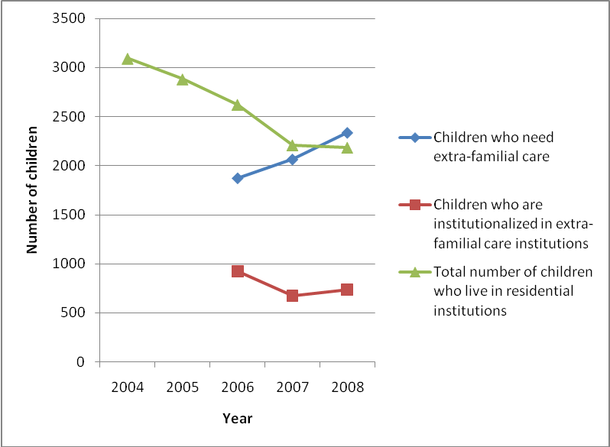
Appendix No.2

Table No.2. State Police registered crime cases of sexual abuse against minors.

 | 2001 | 2002 | 2003 | 2004 | 2005 | 2006 | 2007 | 2008
Rape | 69 | 51 | 73 | 266 | 165 | 38 | 36 | 41
Violent satisfaction of sexual desire | 74 | 53 | 54 | 106 | 134 | 78 | 133 | 66
Seduction in debauchery | 55 | 85 | 72 | 144 | 163 | 29 | 156 | 157
Sexual intercourse with person younger than 16.years of age |  |  |  |  | 0 | 20 | 26 | 41
Forcing to engage in prostitution |  |  |  |  | 0 | 0 | 0 | 0
Total | 198 | 189 | 212 | 516 | 462 | 165 | 351 | 305

Figure No.2. State Police registered crime cases of sexual abuse against minors.

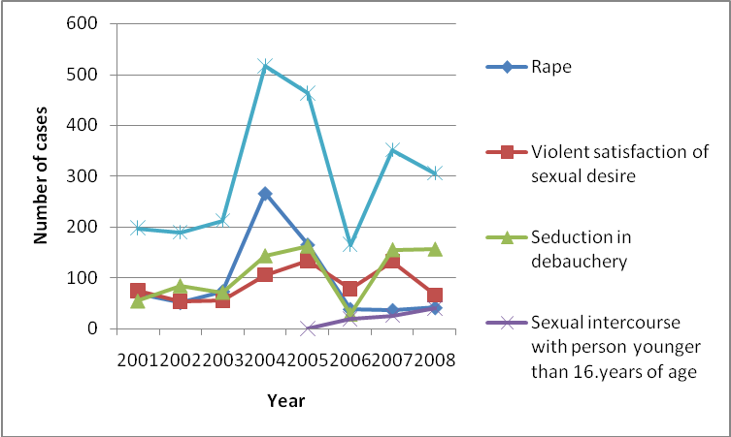
Appendix No.3

Table No.3. Number of heard cases at court on sexual abuse cases against minors

 | 2005 | 2006 | 2007 | 2008
Rape | 76 | 69 | 39 | 39
Violent satisfaction of sexual desire | 91 | 59 | 80 | 73
Sexual intercourse with person younger than 16.years of age
Seduction in debauchery
Kopā | 167 | 128 | 119 | 112

Figure No.3. Number of heard cases at court on sexual abuse cases against minors
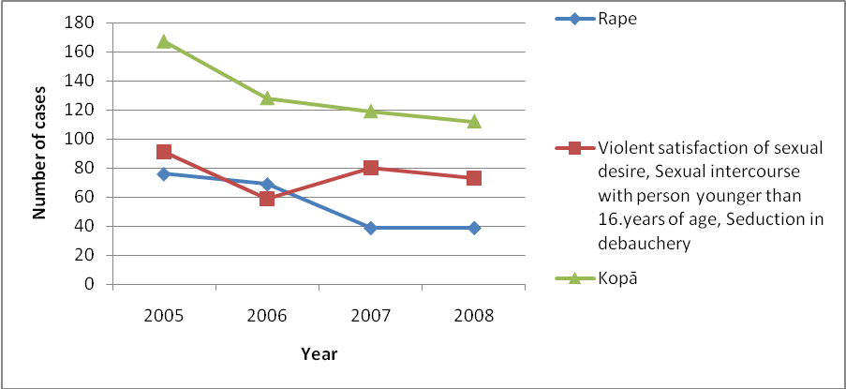
Appendix No.4

Table No.4. Number of registered cases of State inspectorate for protection of children’s rights through children hotline

Sexual abuse | 2006 | 2007 | 2008
Educational institutions
With peers | 137 | 35 | 13
With teachers | 42 | 16 | 10
Total | 179 | 51 | 23
Cure institutions
With peers | 5 | 1 | 1
With teachers | 1 | 0 | 2
Total | 6 | 1 | 3
Family
With parents | 54 | 30 | 36
With grandparents | 0 | 2 | 2
With stepfather, stepmother | 27 | 23 | 8
With brothers, sisters | 32 | 22 | 17
Total | 113 | 77 | 63
Other(not clarified) | 56 | 104 | 59
Total | 425 | 254 | 169

Figure No.4. Number of children (percentage) who declare they have suffered from sexual abuse.

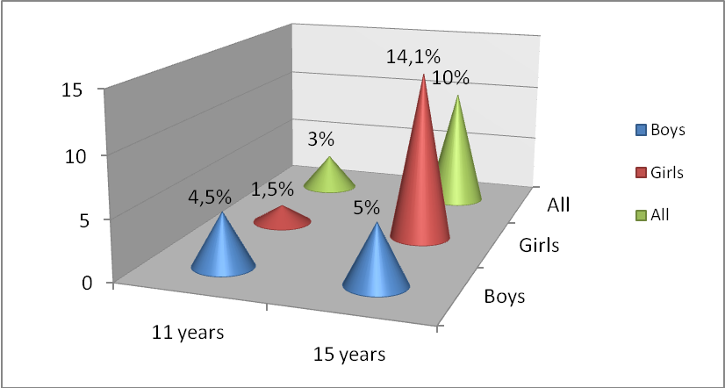
Source: “Factors of marriage, birth and positive relationships between children and parents” Sebre, S., Ļebedeva, L., Trapenciere, I., 2004
Appendix No.5
Table No.5. Latvian Criminal Law: section and Penal Code
Type of crime (according to the Penal Code) | Latvian Criminal Law (CL) section | Expected punishment (according to the Penal Code) |  | Comment (regarding interpretation, international ratified legislation or practice)
Type of crime (according to the Penal Code) | Latvian Criminal Law (CL) section | 14 -18 years of age | under 14 years of age
Debauchery with a minor | Section 162.  Immoral Acts With a Minor | For a person who commits immoral acts with a minor against the will of the minor or if such have been committed by a person who has attained the age of majority,  the applicable sentence is deprivation of liberty for a term not exceeding three years, or custodial arrest. | For a person who commits immoral acts with a juvenile,  the applicable sentence is deprivation of liberty for a term not exceeding six years.
Any kind of sexual intercourse with a child under the age of 18 | Section 161.  Sexual Intercourse, Pederasty and Lesbianism with a Person who has not Attained the Age of Sixteen Years | For a person who commits an act of sexual intercourse, or pederastic, lesbian or other unnatural sexual acts of gratification, with a person who has not attained the age of sixteen years and who is in financial or other dependence on the offender, or if such offence has been committed by a person who has attained the age of majority,  the applicable sentence is deprivation of liberty for a term not exceeding four years. |  | There is one of the highest thresholds regarding agreeing willingly to sexual relationships.  CL does not prescribe sentence for sexual act with a person who has not attained the age of sixteen years, unless it happens against person’s free will.
Rape | Section 159.  Rape | For a person who commits rape where commission is by a person who has previously committed rape or commission is by a group of persons, or who commits rape of a female minor,  the applicable sentence is deprivation of liberty for a term of not less than five years and not exceeding fifteen years, with or without police supervision for a term not exceeding three years. | For a person who commits rape, if serious consequences are caused thereby or commits rape of a female juvenile,  the applicable sentence is life imprisonment, or deprivation of liberty for a term of not less than ten years and not exceeding twenty years, with police supervision for a term not exceeding three years. | Nevertheless the applicable sentence of Section 160 is lower than Section 159, thus legislator considers male sexual abuse less dangerous and victim is less traumatized comparing to analogical action against female.
Incest | No special section
Persuasion of a child to involve in prostitution or other sexual activities | Section 162¹  Compelling engaging in grooming | For a person who commits an act of compelling engaging in grooming or persuasion to meet them with a goal to involve into sexual activities or sexual intercourse, irrespective of the nature of such persuasion, with a person who has not attained the age of sixteen years, if such offence has been committed by a person who has attained the age of majority,  the applicable sentence is deprivation of liberty for a term of not less two years, or custodial arrest, or community service. | For a person who commits compelling engaging in grooming with a juvenile,  the applicable sentence is deprivation of liberty for a term of not less five years | This section inoperative since 27.11.2008.
Profit-driven persuasion of a child to involve in prostitution or other sexual activities | Section 164. Compelling Engaging in Prostitution | For a person who commits inducing or compelling a minor to engage in prostitution, or commits providing premises to minors for purposes of prostitution,  the applicable sentence is deprivation of liberty for a term not exceeding six years, with or without confiscation of property. | For a person who commits inducing or compelling a juvenile to engage in prostitution,  the applicable sentence is deprivation of liberty for a term of not less than five and not exceeding twelve years, with or without confiscation of property.
Persuasion of a child to use narcotic substances and involve in prostitution or other sexual activities | No special section
Exploitation of a child that has already been involved in prostitution or other sexual activities | No special section
Child sexual abuse through the use of Internet | No special section  See section 162¹
Sexual abuse of a child under 14 years of age by forceful persuasion of the child to watch actual or simulated sexual intercourses and other forms of sexual activities | No special section  See section 162.
Sexual abuse of a child by forcing the child to participate in sexual intercourses or to participate in other forms of sexual activities | No special section  See section 162.
Child abduction with the purpose of involving the child in lecherous activities or traffic | Section 154.1  Human Trafficking  A person who commits human trafficking to a foreign state | For a person who commits the same acts if commission thereof is with respect to a minor, or by a group of persons pursuant to prior agreement, are caused thereby,  the applicable sentence is deprivation of liberty for a term of not less than five years and not exceeding twelve years, with confiscation of property. | For a person who commits the same acts, if serious consequences are caused thereby or commission thereof is with respect to a juvenile, or by an organised group of persons,  the applicable sentence is deprivation of liberty for a term of not less than ten years and not exceeding fifteen years, with confiscation of property.
Homosexual activities with minors and underage children | Section 160.  Forcible Sexual Assault  A person who commits pederastic or lesbian or other unnatural sexual acts of gratification, if such acts have been committed using violence or threats or by taking advantage of the state of helplessness of a person | For a person who commits the same acts, if commission thereof is on a minor, or is repeated, or by a person who has previously committed rape, or by a group of persons,  the applicable sentence is deprivation of liberty for a term of not less than three years and not exceeding twelve years and with police supervision for a term not exceeding three years. | For a person who commits acts provided for in Paragraphs one or two of this Section, if serious consequences are caused thereby, or if commission thereof is on a juvenile,  the applicable sentence is life imprisonment, or deprivation of liberty for a term of not less than ten years and not exceeding twenty years, with police supervision for a term not exceeding three years.
Usage of pornographic materials with the purpose of involving children in pornography | Section 166.  Violation of Provisions Regarding Importation, Production and Distribution of Pornographic or Erotic Materials | For a person who commits the importation, production, public demonstration, advertising or other distribution of such pornographic or erotic materials as relate or portray the sexual abuse of children, bestiality, necrophilia or violence of a pornographic nature, or the keeping of such materials for similar purposes,  the applicable sentence is deprivation of liberty for a term not exceeding three years, or a fine not exceeding fifty times the minimum monthly wage, with or without confiscation of property.
 |  | For a person who commits procurement or utilisation of minors in the production (manufacturing) of pornographic or erotic materials,  the applicable sentence is deprivation of liberty for a term not exceeding six years, or a fine not exceeding eighty times the minimum monthly wage, with or without confiscation of property. | For a person who commits procurement or utilisation of juveniles in the production (manufacturing) of pornographic or erotic materials,  the applicable sentence is deprivation of liberty for a term of not less than five and not exceeding twelve years, with or without confiscation of property.

Appendix No.6

Figure No.5. The structure of the residential institution system

Ministry of Welfare
Ministry of Education and Science

Municipality

Children social care centers
(0-2 yrs all children)
(0-4 yrs mentally and physically handicapped)
(0-18 yrs mentally handicapped)
Children’s home
(long-term care)
(2-18 yrs)

Boarding school
(From 7 yrs)

Family

Appendix No.7

Figure No.6. Premises of Dzimba’s safety school and safety trip

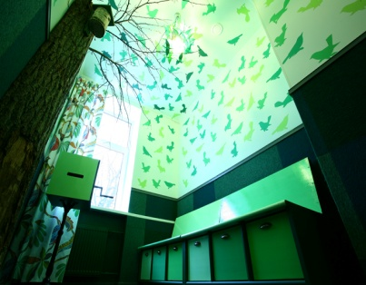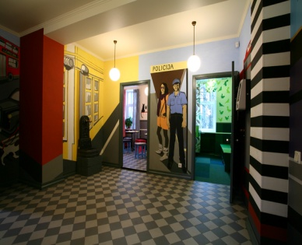

Figure No.7. Dzimba.

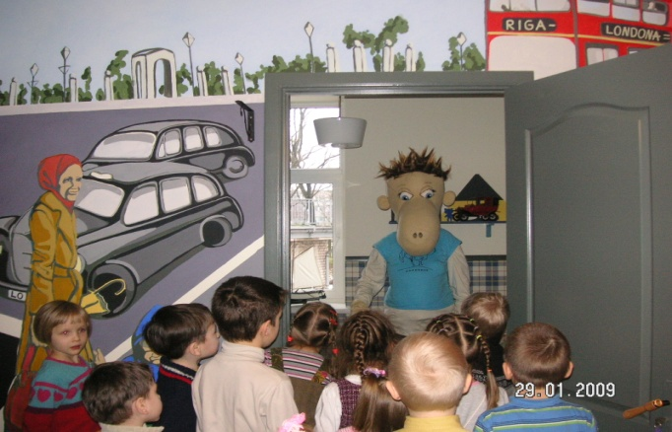

Analyzing laws and regulations, there are two areas of sexual abuse: -First of all, children (commercial) sexual exploitation, with which should be understood such kind of sexual abuse where third party get material wealth or child is offered material wealth, including: children trafficking; children pornography and children prostitution, including sex tourism; international laws and regulations mostly regulate particularly this sphere; -Secondly, child sexual abuse that includes sexual abuse in family and other kind of sexual abuse, where tyrant’s goal is not to get material wealth. This sphere is particularly analyzed in this document.
Latvia has not signed or validated the mentioned convention. The process of alignment between Latvian ministries about possibility to sign the convention, taking into account, that in order to fully implement the convention, additional finances will be needed, as well as there is a discussion whether Latvian laws and regulations conform with separate requirements of convention regarding extraterritorial jurisdiction, etc. Besides there is another discussion about new draft Council of Europe framework Decision on combating sexual exploitation of children and child pornography, which would replace framework Decision 2004/68/TI in force. Most of the norms mentioned in Council of Europe Convention are included in the draft.

